**I. Identify the Process Model you use in your project. List down the required task sets**

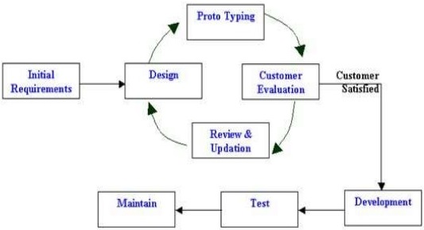

**Required Task Sets**

**Initial Requirements**

This stage involves understanding the very basics product requirements especially in terms of user interface. The more intricate details of the internal design and external aspects like performance and security can be ignored at this stage.

**Design**

In this stage the system and software design is prepared from the requirement specifications which were studied in the first stage. System Design helps in specifying hardware and system requirements and also helps in defining overall system architecture. The system design specifications serve as input for the next phase of the model.

**Prototyping**

An initial prototype is developed in this stage, where the very basic requirements are showcased and user interfaces are provided. These features may not exactly work in the same manner internally in the actual software developed. While, the workarounds are used to give the same look and feel to the customer in the prototype developed.

**Customer Evaluation**

The prototype developed is then presented to the customer. The feedback is collected in an organized manner and used for further enhancements in the product under development.

**Review & Updates**

The review and feedbacks are then discussed in this stage and some negotiations happen with the customer based on factors like – time and budget constraints and technical feasibility of the actual implementation. The changes accepted are again incorporated in the new prototype developed and the cycle repeats again until the customers are satisfied.

**Development**

This stage is where the development of the actual system based on the prototype is started, using the feedbacks from the customer’s review of the prototype illustrated by the proponents.

**Test**

This stage refers to the testing only stage of the product where product defects are reported, tracked, fixed and retested, until the product reaches the quality standards defined in the SRS.

**Maintain**

This is the stage where maintenance is done for the existing customer base. This is also where changes are made to initial software. It involves continuous evaluation of the system in terms of its performance.